WHAT IS PERSONAL DATA?
Personal data is information that is related to a single person, such as his/her name, age, medical history, diagnosis etc.

WHAT IS CONSENT?
Consent is permission from patients – an individual’s consent is defined as:-
- Any freely given
- Specific and informed
- Indication of his/her wishes by which the data subject (patients) agrees to relevant personal data being processed.
The changes in GDPR mean that we must get explicit permission from patients when using their data. Your healthcare is implied consent. This is to protect your right to privacy and we may ask you to provide consent to do certain things like contact you or record certain information about you in your clinical/staff records.
Individuals have a right to withdraw consent at any time.

For further information about how the practice complies with GDPR, you can contact the Business Manager at admin.isca@nhs.net


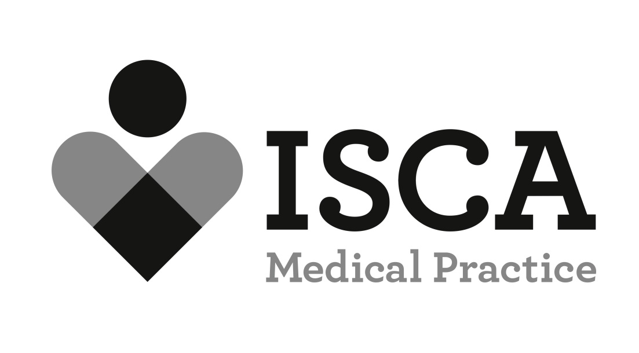

38 Polsloe Road, Exeter, EX1 2DW

What is GDPR?

General Data Protection Regulations

GDPR
- GDPR will supersede the Data Protection Act. It is similar to the Data Protection Act (DPA)1998, which the practice already complies with but strengthens many of the DPA’s principles.
- GDPR is a new law that determines how your personal data is processed, kept safe and the legal rights that you have in relation to your own data. The regulation applies from 25 May 2018.

WHAT GDPR WILL MEAN FOR PATIENTS

YOUR DATA
- must be processed lawfully, fairly and transparently.

- collected for specific, explicit and legitimate purposes.

- must be limited to what is necessary for the purposes for which it is processed.

- must be accurate and kept up to date.

- must be held securely.

- It can only be retained for as long as is necessary for the reasons it was collected.

PATIENTS RIGHTS
- Being informed about how their data is used.

- To have access to their own data.

- To ask to have incorrect information changed.

- To restrict how their data is used.

- Move their patient data from one organisation to another.

- To object to their personal information being processed (in certain circumstances).

THE MAIN CHANGES

- The Practice must comply with Subject Access Requests (SAR’s) - a written signed request from an individual to see what information is held about them - like where we require your consent to process data. This must be freely given, specific, informed and unambiguous. We cannot charge for SAR’s and must respond with 30 days.

- New special protection for personal data.

- The Information Commissioner’s Office must be notified within 72 hours of a data breach.

- Higher fines for data breaches.

